Supplementary material

Supplementary Table 1. Gantt chart for CPReCoder study.
Activity | Time
 | Mar–Aug 2020 | Sep 2020–Feb 2021 | Mar–Jun 2021 | Jul 2021–Aug 2021 | Aug–Oct 2021 | Sep–Oct 2021 | Nov–Dec 2021 | Jan–Jun 2022
Application Development (Phase I) | Development Planning | Observations and Problem Identification | Wireframe Design and Initial Testing | Feedback Integration and Finalization
Simulation Study (Phase II) |  |  | Study Design and IRB approval | Study Setup | Simulation Execution
Data Collection |  |  |  |  | Data Collection
User Experience Assessment (Phase III) |  |  |  |  | SUS Scoring | Interviews
Data Analysis |  |  |  |  |  |  | Initial Analysis
Final Analysis & Manuscript Preparation |  |  |  |  |  |  |  | Analysis and Writing
IRB, institutional review board; SUS, system usability scale.
Development Planning: Initial meetings, setting application objectives; Observations and Problem Identification: Gathering insights from medical personnel and identifying issues with current CPR recording methods; Wireframe Design and Initial Testing: Creating the application's initial design and conducting preliminary tests; Feedback Integration and Finalization: refining the application based on feedback and finalizing the design; Study Design and IRB Approval: Planning the simulation study and waiting for IRB approval; Study Setup: Preparing the simulation environment; Simulation Execution: Conducting the simulation study, Data Collection: Gathering data from the simulation study; SUS Scoring: Conducting System Usability Scale assessments; Interviews: Conducting semi-structured interviews; Initial Analysis: Preliminary analysis of the collected data; Analysis and Writing: Final data analysis and manuscript preparation.

Supplementary Table 2. System usability scale questionnaire.
For each of the following statements, please mark one box that best describes your reactions to the APP today.
 |  | SD | D | N | A | SA
1 | I think that I would like to use the APP frequently. | 1 | 2 | 3 | 4 | 5
2 | I found the APP unnecessarily complex. | 1 | 2 | 3 | 4 | 5
3 | I thought the APP was easy to use. | 1 | 2 | 3 | 4 | 5
4 | I think that I would need the support of a technical person to be able to use the APP. | 1 | 2 | 3 | 4 | 5
5 | I found the various functions in the APP were well integrated. | 1 | 2 | 3 | 4 | 5
6 | I thought there was too much inconsistency in the APP. | 1 | 2 | 3 | 4 | 5
7 | I would imagine that most people would learn to use the APP very quickly | 1 | 2 | 3 | 4 | 5
8 | I found the APP very cumbersome (awkward) to use. | 1 | 2 | 3 | 4 | 5
9 | I felt very confident using the APP. | 1 | 2 | 3 | 4 | 5
10 | I needed to learn a lot of things before I could get going with the APP. | 1 | 2 | 3 | 4 | 5
SD, strongly disagree; D, disagree; N, neutral; A, agree; SA, strongly agree.

Supplementary Table 3. Examples of interview questions.
Engagement and intention to use
• What are your general opinions about the application?
• What impressed you about the application?
• Would you be willing to use this application in the clinical field?
• What are your opinions on the possibility of implementing this application in clinical practice?
Information processing & quality
• Does the application include enough details for CPR records? What would you like to include or eliminate?
• What were the pros and cons of the application-based recording method compared to the handwritten or web-based methods that had been used before?
Functionality
• What do you think of the application’s user interface?
• What inconveniences did you experience when you used the application?
• Did you experience any challenges when using the application?
Suggestion for improvement
• Which component of the application would you like to improve?
• What are the risks associated with using this application in clinical settings?
CPR, cardiopulmonary resuscitation.

Supplementary Table 4. Baseline characteristics of the participants.
Study participants
(N = 16)
Age (yr) |  | 32 (27.5–39.5)
Sex, female |  | 14 (87.5%)
Occupation
 | Emergency medicine physician | 4 (25%)
 | Emergency room nurse | 9 (56.3%)
 | Emergency medical technician | 3 (18.8%)
Clinical experience (yr) |  | 7.5 (3.5–12.5)
BLS provider* |  | 12 (75%)
ACLS provider* |  | 12 (75%)
Institutional CPR training |  | 16 (100%)
*Certified by the American Heart Association. BLS, basic life support; ACLS, advanced cardiac life support; CPR, cardiopulmonary resuscitation. Data are presented as median with interquartile ranges or frequency (%).

Supplementary Table 5. System usability scale of each participant.
Participant | Question |  |  |  |  |  |  |  |  |  | SUS score
 | q1 | q2 | q3 | q4 | q5 | q6 | q7 | q8 | q9 | q10
p1 | 5 | 2 | 5 | 1 | 3 | 1 | 5 | 2 | 4 | 1 | 87.5
p2 | 5 | 1 | 4 | 2 | 5 | 1 | 5 | 1 | 4 | 1 | 92.5
p3 | 5 | 2 | 4 | 2 | 4 | 2 | 4 | 2 | 5 | 2 | 80.0
p4 | 5 | 1 | 5 | 2 | 4 | 1 | 5 | 1 | 5 | 1 | 95.0
p5 | 5 | 2 | 5 | 1 | 5 | 1 | 5 | 1 | 5 | 1 | 97.5
p6 | 5 | 2 | 5 | 2 | 4 | 2 | 5 | 1 | 5 | 3 | 85.0
p7 | 5 | 2 | 5 | 1 | 5 | 2 | 5 | 2 | 5 | 1 | 92.5
p8 | 5 | 4 | 5 | 1 | 5 | 2 | 5 | 1 | 5 | 2 | 87.5
p9 | 4 | 2 | 4 | 2 | 4 | 2 | 4 | 1 | 3 | 2 | 75.0
p10 | 5 | 1 | 5 | 1 | 5 | 1 | 5 | 1 | 5 | 1 | 100.0
p11 | 4 | 2 | 5 | 2 | 4 | 1 | 4 | 2 | 5 | 1 | 85.0
p12 | 4 | 2 | 4 | 2 | 4 | 1 | 4 | 2 | 4 | 2 | 77.5
 |  |  |  |  |  |  |  |  |  |  | 87.9*
SUS, system usability scale. * Mean of SUS scores.

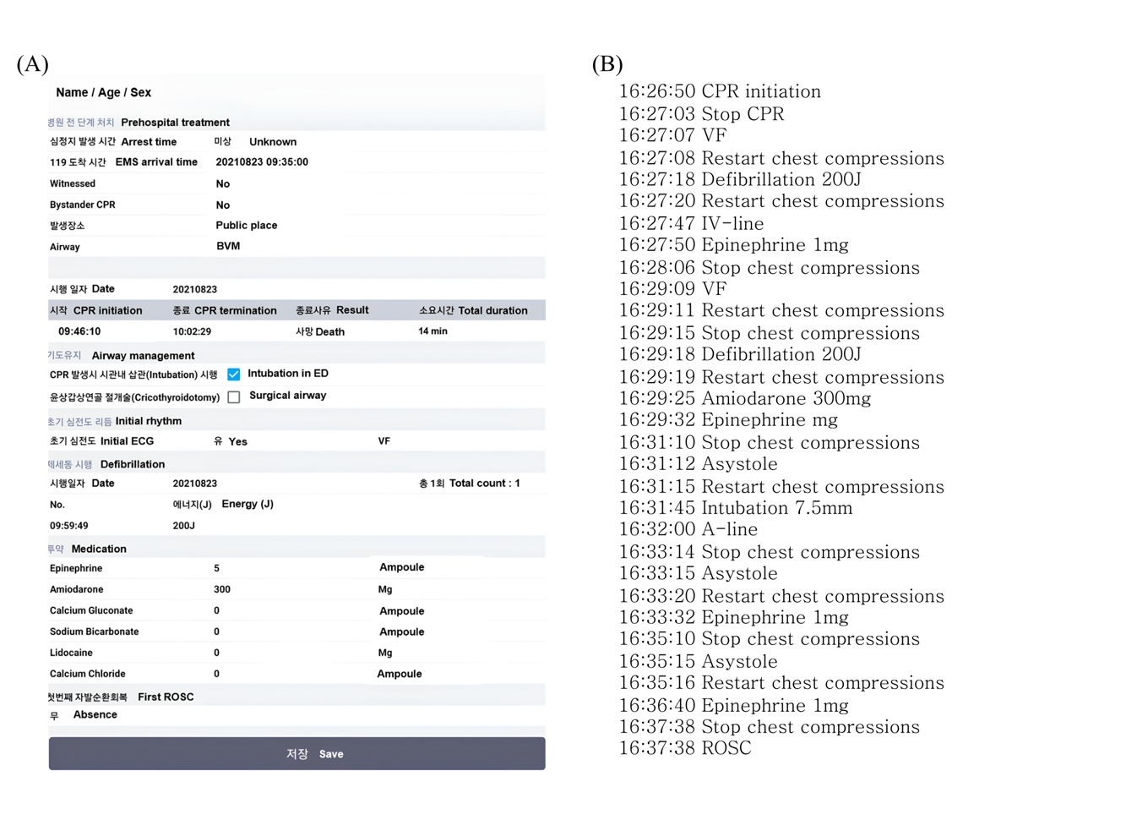
Supplementary Fig. 1. Example screenshot of the final report from CPReCoder. (A) an image file modeled after the hospital’s CPR documentation form, and (B) a text file that records all entered information chronologically. English explanations are added to the Korean text to facilitate comprehension for the readers. BVM, bag-valve-mask ventilation; CPR, cardiopulmonary resuscitation; ECG, electrocardiogram; VF, ventricular fibrillation; ROSC, return of spontaneous circulation.

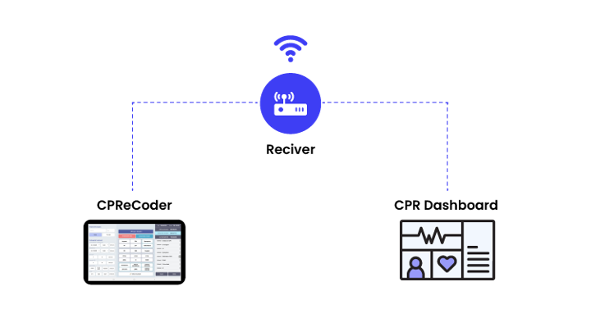
Supplementary Fig. 2. Diagram of the dashboard system for cardiopulmonary resuscitation. The application transfers data to the dashboard in real-time, and includes interventions, administered medications, and relevant patient information, allowing the CPR team to review the current situation on-site. The dashboard system does more than just display information entered into the application; it also includes features intended to reduce the cognitive load on the CPR team. In addition, it also displays real-time CPR quality metrics like the chest compression fraction. CPR, Cardiopulmonary resuscitation.

